A2637-US-MA-Swampscott-Archaic Biface-Granite

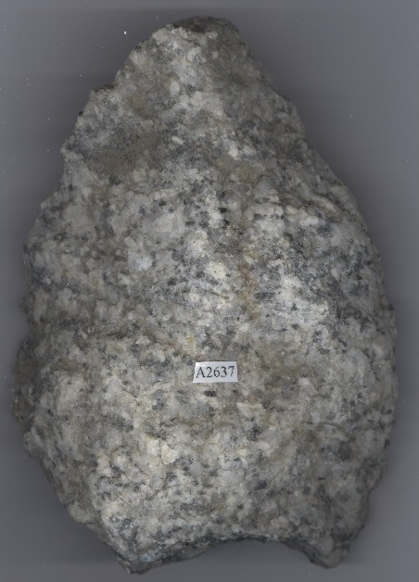 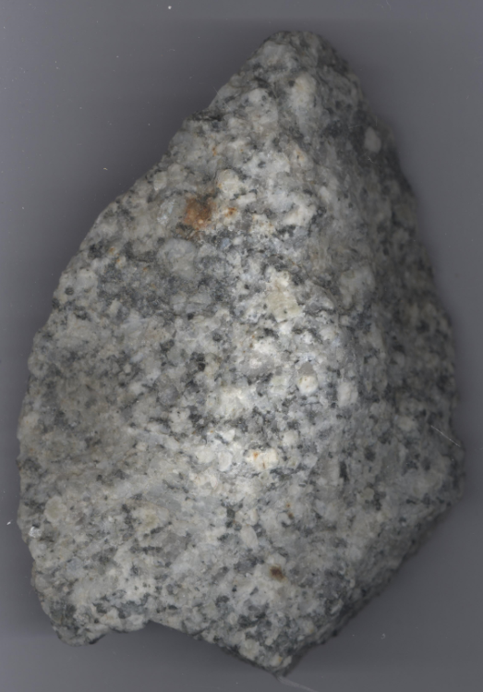

This rare, bifacial axe with an incurvate base, nicely excurvate sides had just been knapped on Phillips Beach, Swampscott when it was left by an Algonquian Indian who spoke a dialect call Natick. Then it was buried in the sand for five thousand years until a 2018 summer storm uncovered it and Susan Murcott found it as though it had just been knapped. It is knapped from a granite that is known from the area around Conway, NH. The boulder from which this was knapped had been deposited during the last glaciation ca. 15-13,000 BP (before the present). The axe, itself, dates to the archaic period about 5,000 BP when animals that would have been worthy of such a big weapon were roaming the area, such as caribou and elk.